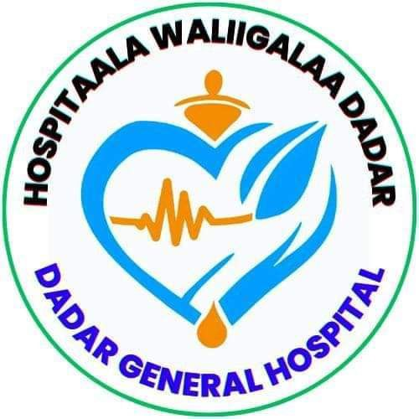

DEDER GENERAL HOSPITAL
Hand Hygiene Compliance Assessment Report

Report period: 3rd Quarter of 2017EFY

Conducted By: IPC Committee

March 2017E.C
Deder, Oromia
IPC Committee Member
No | Name | Position | Role
 | Dr. Derese Gosa | Medical Director | Chairperson
 | Hamza Jemal | Head Nurse/Matron | Vice Chairperson
 | Abdi Tofik | Quality & Safety Unit head | Member
 | Addisu Wondimu | OR/Obs/Gyn Head | Member
 | Alamudin Usmail | Laboratory Head | Member
 | Jafer Dine | TB Clinic Head | Member
 | Kalifa Jemal | Surgical Ward head | Member
 | Chala Abdusalam | Pediatrics Head | Member
 | Balisa usmail | Pharmacy Head | Member
 | Obsa Usmail | Finance and Property head | Member
 | Nure Jemal | Maintenance Officer | Member
 | Kadir hasen sali | Laundry Service head | Member
 | Desta Tafesa | Cleaner Head | Member

TABLE OF CONTENTS
Introduction 1
Purpose 2
Scope 2
Methodology. 2
Results 3
1. hand hygiene Compliance Assessment results per Ward/Unit 3
2. According to Professional categories. 8
3. HH Compliance According to Indications 9
4. Deder General Hospital Overall Hand Hygiene compliance rate 10
Recommendations/Interventions. 12

LISTS OF TABLE AND FIGURES
Table 1: Action plan to improve hand hygiene compliance, 2017E.C 20
Table 2: Implementation Status Report of previous Hand Hygiene Action Plan, March 2017 21

Figure 1: Deder General Hospital Hand Hygiene Compliance according to Ward/Unit, March 2017E.C 3
Figure 2: Deder General Hospital Hand Hygiene Compliance According to Professional categories, March 2017E.C 8
Figure 3: Deder General Hospital Hand Hygiene Compliance According to Indications, March 2017E.C 9
Figure 4: Deder General Hospital Overall Hand Hygiene compliance rate, March 2017E.C 11

Introduction
Hand hygiene is a fundamental practice in HC settings to prevent HAIs. Despite its importance, hand hygiene compliance among HCWs remains suboptimal. Assessing HH compliance is essential to identify gaps in compliance and design interventions to improve adherence to hand hygiene protocols.
Definition of terms
- Hand Hygiene: practice of cleaning one’s hands to prevent spread of disease-causing bugs. This can be done by Hand Washing with clean water and soap or by Hand rubbing using ABHR.
- Actions: steps and practices undertaken to keep hands clean. In this case HW or HR. However other examples are: drying hands with a clean towel or air dry, not touching your face, mouth or nose with unclean hands, covering your mouth and nose with tissue or elbow when coughing or sneezing, not touching surfaces frequently touched, HW before food eating, or using places of convenience, keep your nails trimmed and clean etc.
- Opportunity: Such a time when one must practice hand Hygiene.
- Indication: Reason for which one must perform Hand Hygiene at a given time. These are derived from the WHO 5 Moments of Hand Hygiene. Before touching a patient, before Clean/Asceptic procedure, After body fluid exposure risk, After touching a patient, After Touching patient surrounding.
- Hand Hygiene compliance: extent to which HCWs, patients and visitors adhere to practicing hand hygiene. Calculated as (Actions/Opportunitiesx100). Reflected as a percentage score.

Purpose
This assessment report provides an overview of HH compliance in Gulu Regional Referral Hospital. This data shall act as a baseline for improvement in compliance henceforth

Scope
The assessment was conducted in the month of March 2017E.C. However, this shall be repeated quarterly to measure progress visa vie interventions put in place.

Methodology.
The assessment employed use of a draft of Hand Hygiene Observation Form Adapted by the MoH from WHO.
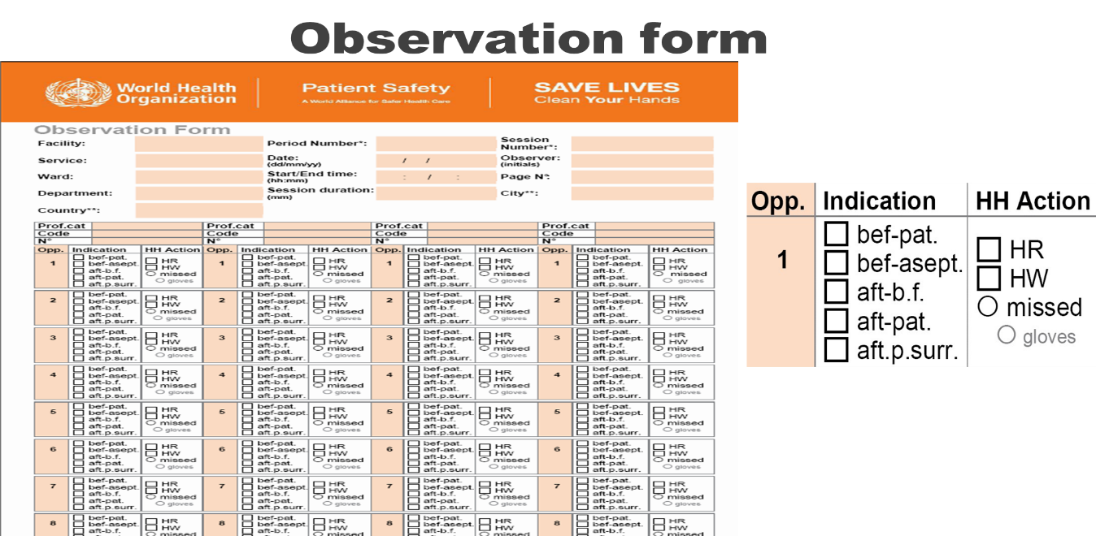

The assessment targeted attainment of 160 opportunities per unit, 40 opportunities per professional category. The observers split the observation into 2 sessions per unit within the 2 weeks.

Results

hand hygiene Compliance Assessment results per Ward/Unit
The Operation Theatre (OR) achieved near-perfect compliance at 95%, setting a benchmark for all units. Emergency/ICU (85%), NICU (80%), and Pediatrics (75%) demonstrated strong adherence. Surgical Ward (65%), Gynae/Obstetrics (70%), and Medical Ward (60%) showed moderate performance, while Outpatient (OPD) lagged significantly at 58%, highlighting critical gaps in high-traffic areas.

Figure 1: Deder General Hospital Hand Hygiene Compliance according to Ward/Unit, March 2017E.C

- Outpatient Department (OPD)
Number of Observation sessions conducted: 2
Actual opportunities observed: 100
Average opportunities observed per professional category: 58
Outpatient Department (OPD)
Professional Category | Number of Hand Hygiene Actions | Compliance (%) (Action/Opportunities)
Medical Doctor | HW: 16, HR: 9 | 96%
Nurses | HW:17, HR:8 | 80%
Axillary | HW: 16, HR:9 | 56%

Total number of hand hygiene opportunities performed
Hand Washing : 49 Hand rubbing : 26
Hand Hygiene Compliance of the ward: $\frac{Total actions}{Total opportunities}*100=\frac{75}{100}*100=58\%$

- Medical Ward
Number of Observation sessions conducted: 2
Actual opportunities observed: 128
Average opportunities observed per professional category: 77

Professional Category | Number of Hand Hygiene Actions | Compliance (%) (Action/Opportunities)
Medical Doctor | HW: 4, HR: 10 | 70%
Nurses | HW: 5, HR: 9 | 68%
Axillary | HW: 4, HR: 6 | 48%

Total number of hand hygiene opportunities performed
Hand Washing : 40 Hand rubbing : 37
Hand Hygiene Compliance of the ward: $\frac{Total actions}{Total opportunities}*100=\frac{77}{128}*100=60\%$
- Surgical Ward
Number of Observation sessions conducted: 2
Actual opportunities observed: 120
Average opportunities observed per professional category: 38
Professional Category | Number of Hand Hygiene Actions | Compliance (%) (Action/Opportunities)
Medical Doctor | HW: 4, HR: 8 | 60%
Nurses | HW: 6, HR: 10 | 73%
Axillary | HW: 5, HR: 5 | 50%

Total number of hand hygiene opportunities performed
Hand Washing : 48 Hand rubbing : 30
Hand Hygiene Compliance of the ward: $\frac{Total actions}{Total opportunities}*100=\frac{78}{120}*100=65\%$
- Pediatrics Ward
Number of Observation sessions conducted: 2
Actual opportunities observed: 96
Average opportunities observed per professional category: 46
Professional Category | Number of Hand Hygiene Actions | Compliance (%) (Action/Opportunities)
Medical Doctor | HW: 5, HR: 10 | 47%
Nurses | HW: 16, HR: 8 | 75%
Axillary | HW: 4, HR: 3 | 22%
Total number of hand hygiene opportunities performed
Hand Washing : 52 Hand rubbing : 20
Hand Hygiene Compliance of the ward: $\frac{Total actions}{Total opportunities}*100=\frac{72}{96}*100=75\%$

- Emergency and ICU
Number of Observation sessions conducted: 2
Actual opportunities observed: 128
Average opportunities observed per professional category: 73
Professional Category | Number of Hand Hygiene Actions | Compliance (%) (Action/Opportunities)
Medical Doctor | HW: 15, HR: 10 | 78%
Nurses | HW: 20, HR: 10 | 94%
Axillary | HW: 14, HR: 4 | 56%
Total number of hand hygiene opportunities performed
Hand Washing : 60 Hand rubbing : 49
Hand Hygiene Compliance of the ward: $\frac{Total actions}{Total opportunities}*100=\frac{109}{128}*100=85\%$

- Gynae/Obstetrics Ward
Number of Observation sessions conducted: 2
Actual opportunities observed: 60
Average opportunities observed per professional category: 26
Professional Category | Number of Hand Hygiene Actions | Compliance (%) (Action/Opportunities)
Medical Doctor | HW: 4, HR: 6 | 67%
Midwives | HW: 5, HR: 5 | 67%
Axillary | HW: 3, HR: 3 | 50%
Total number of hand hygiene opportunities performed
Hand Washing : 30 Hand rubbing : 12
Hand Hygiene Compliance of the ward: $\frac{Total actions}{Total opportunities}*100=\frac{42}{60}*100=70\%$

- NICU
Number of Observation sessions conducted: 2
Actual opportunities observed: 128
Average opportunities observed per professional category: 64
Professional Category | Number of Hand Hygiene Actions | Compliance (%) (Action/Opportunities)
Medical Doctor | HW: 15, HR: 7 | 69%
Nurses | HW: 20, HR: 5 | 78%
Axillary | HW: 13, HR: 4 | 53%
Total number of hand hygiene opportunities performed
Hand Washing : 70 Hand rubbing : 32
Hand Hygiene Compliance of the ward: $\frac{Total actions}{Total opportunities}*100=\frac{102}{102}*100=80\%$

- Operation Theatre Room (OR)

Number of Observation sessions conducted: 2
Actual opportunities observed: 29
Average opportunities observed per professional category: 26
Professional Category | Number of Hand Hygiene Actions | Compliance (%) (Action/Opportunities)
Medical Doctor | HW: 5, HR: 5 | 100%
Nurses | HW: 7, HR: 3 | 100%
Axillary | HW: 2, HR: 4 | 80%
Total number of hand hygiene opportunities performed
Hand Washing : 18 Hand rubbing : 10
Hand Hygiene Compliance of the ward: $\frac{Total actions}{Total opportunities}*100=\frac{28}{29}*100=95\%$

According to Professional categories.

Medical doctors and nurses consistently outperformed auxiliary staff. In Emergency/ICU, nurses led (94%), while auxiliary staff lagged (56%). Pediatrics saw nurses at 75% compliance, but auxiliary staff plummeted to 22%, exposing systemic inequities in training and resource access.

Figure 2: Deder General Hospital Hand Hygiene Compliance According to Professional categories, March 2017E.C

HH Compliance According to Indications
Analysis of hand hygiene compliance according to WHO's "5 Moments" revealed significant variation, with the strongest adherence (>80%) observed "After Body Fluid Exposure," indicating high awareness of immediate contamination risks; conversely, compliance was weakest (<45%) for the preventive moments "Before Touching a Patient" and "Before a Clean/Aseptic Procedure," suggesting neglect of proactive infection control measures, while adherence "After Touching Patient Surroundings" was the poorest at approximately 30%, highlighting a critical underestimation of environmental transmission risks (Figure 3).
Figure 3: Deder General Hospital Hand Hygiene Compliance According to Indications, March 2017E.C

Deder General Hospital Overall Hand Hygiene compliance rate
This was calculated by adding the cumulative ward/unit actions against cumulative corresponding opportunities.

Category | OPD | MW | SW | PW | ICU & Eme | GNOBS | NICU | OR | TOTAL
AC | 75 | 77 | 78 | 72 | 109 | 42 | 102 | 28 | 656
OPP | 100 | 128 | 120 | 96 | 128 | 60 | 128 | 29 | 820

- Total action = 656
- Cumulative opportunities observed = 820
- DGH HH compliance: $\frac{Total actions}{Total opportunities}*100=\frac{656}{820}*100=80\%$

Deder General Hospital (DGH) demonstrated a high overall hand hygiene compliance rate of 80% in March 2017 E.C., indicating that a significant majority of hand hygiene opportunities (80%) were achieved, highlighting a reduced infection prevention and control challenge within the facility.

Figure 4: Deder General Hospital Overall Hand Hygiene compliance rate, March 2017E.C

Recommendations/Interventions.
- Strengthen Auxiliary Staff Engagement
- Improve Hand Hygiene Infrastructure
- Reinforce Preventive Compliance Moments
- Enhance Accountability Through Regular Feedback
Table 1: Action plan to improve hand hygiene compliance, 2017E.C
Strategic Area | Action | Proposed Corrective Actions | Responsible | Timeline
System Change | Install remaining 8 out of 12 planned sinks in high-traffic areas | 1. Revise budget plan and prioritize IPC infrastructure  2. Seek external donor support or government grants | Hospital Admin, Finance, Maintenance | Within 2 months
System Change | Ensure uninterrupted supply of ABHR and soap in all wards | 1. Implement monthly forecasting using past consumption trends  2. Assign a focal person for IPC supply monitoring  3. Establish buffer stock (min-max levels) | Pharmacy, Store, IPC | Immediate and ongoing
Safety Culture & Leadership | Appoint HH champions in all units (2 pending) | 1. Send formal communication to unit heads to nominate staff  2. Provide clear TOR for HH champions  3. Train newly appointed champions | IPC Committee, Unit Heads | Within 1 month
System Change | Visual reminders not deployed in Gyn/Obs due to wall space limitations | 1. Use mobile reminder boards or door posters  2. Place reminders on equipment or hand sanitizer dispensers | IPC Focal, Gyn/Obs Unit In-charge | Within 2 weeks

Table 2: Implementation Status Report of previous Hand Hygiene Action Plan, March 2017
Strategic Area | Action | Responsible | Timeline | Status | Progress Update
Education & Training | Conduct quarterly HH training for all HCWs, interns, and students | IPC Focal Person, HR | Quarterly | Completed | Training held in Jan 2017; auxiliary staff participation was low (45%).
System Change | Install additional sinks in high-traffic areas and wards | Hospital Admin, Maintenance | By March 2017 E.C | Delayed | Only 4/12 sinks installed due to budget constraints.
System Change | Ensure continuous supply of soap/ABHR | Pharmacy, Store, IPC | Monthly | Partially Done | ABHR supply stable in OR/ICU; shortages reported in Medical/Surgical wards.
Reminders & Communication | Display visual reminders in all wards (posters, cue cards) | IPC, Unit In-charges | Bi-monthly review | Completed | WHO "5 Moments" posters displayed in 90% of units; Gyn/Obs lacks wall space.
Safety Culture & Leadership | Appoint HH champions per ward/unit | IPC Committee | By Oct 2017 E.C | Partially Done | Champions appointed in 7 of 9 units; Medical Ward and Pharmacy still pending.
Safety Culture & Leadership | Unit in-charges to serve as HH role models | Unit Heads | Ongoing | Inconsistent | OR/ICU showed good role modeling; weak in Medical/Surgical wards.
Safety Culture & Leadership | Introduce monthly 'HH Reminder Day' | IPC Team | Starting Jan 2017 | Completed | Launched in Jan 2017; highest participation in Pediatrics (78%), lowest in Surgery (35%).

